Global 4G population coverage reached 80% in 2019 and expected to hit over 90% in 2025. 3G coverage is at 87% at the end of 2017, average monthly price for 500MB was at 2.5% of GDP per capita in 2017 (globally).

Some of the cheaper US LTE plans:
T-Mobile $15 2GB 4G
Cricket Wireless $15 2GB 4G at 8Mbps
Google Fi $30+$10/GB 1GB 4G
Boost Mobile $35 3GB 4G

Average US broadband internet cost
$50 per month in promo period, $60 after

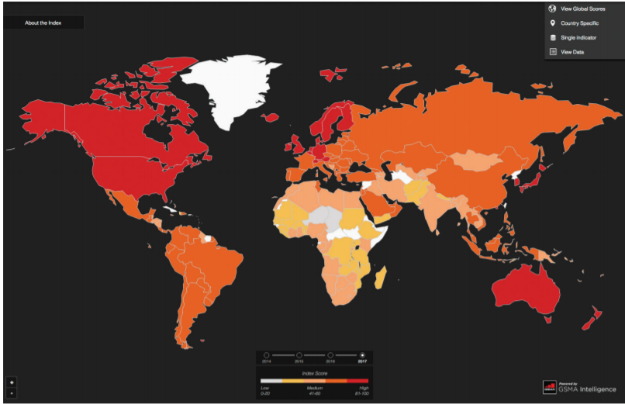

ericsson.com/en/mobility-report/reports/june-2020/network-coverage#:~:text=Global%204G%20population%20coverage%20was,capacity%20and%20faster%20data%20speeds.

https://www.gsma.com/mobilefordevelopment/wp-content/uploads/2018/09/State-of-Mobile-Internet-Connectivity-2018.pdf

https://www.androidcentral.com/these-are-cheapest-data-plans-you-can-buy-us
https://www.highspeedinternet.com/resources/how-much-should-i-be-paying-for-high-speed-internet-resource#:~:text=The%20average%20advertised%20package%20for,after%20the%20promotional%20period%20ends.

